GROUP NO : 02

MEMBERS :

1. Nayamet Ullah (19-39295-1)
2. MD. JAHIDUL ISLAM NOOR (19-39306-1)
3. S.M Nahid (19-39998-1)
4. SHAKRIN JAHAN MOZUMDER (19-39886-1)

**Renting Valuable Stuff**

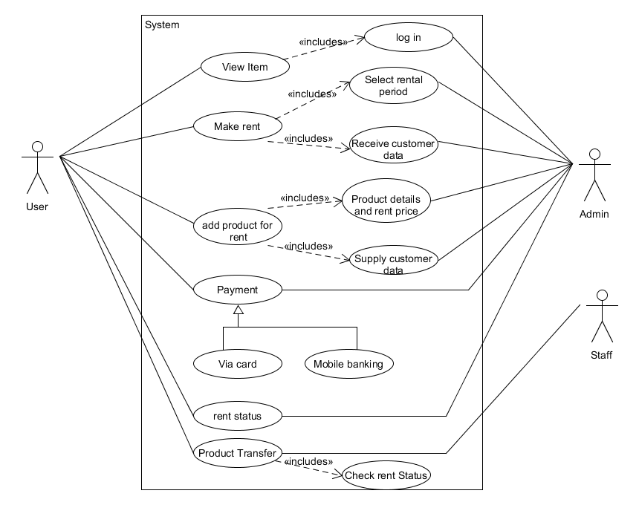**USECASE** :

**MOC Design :**

